Loop 1: Lea & Ash Route  (10.5K Route)  Loop 1 is for ALL RUNNERS .  10K, Half Marathon & Marathon. | 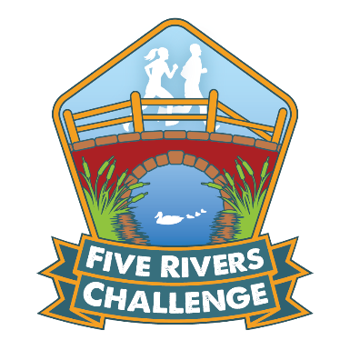

L = Left R = Right TL = Turn Left TR= Turn Right
BL = Bear Left BR= Bear Right LHS = Left hand side RHS = Right hand side
X = Cross Rd = Road FP = Footpath WM = Waymarker
KG= Kissing gate

Distance (km) | Directions
 | TL onto tow path – X small footbridge and take L fork keeping River LEA close on L to Rd.
1.0 | Care X Rd – bear slightly L to X Rd and pick up towpath with River LEA on L.
 | Carry on along towpath for 450m then take steps to X first bridge over River LEA then TR with river now on R.
 | Past 3 small brick buildings on R and continue on tarmac path.
2.9 | Immediately before next bridge on R bear L on tarmac path.
 | At path fork BR and continue straight on gravel track and X wooden bridge over River ASH
3.4 | Continue through KG and under bridge. Continue straight ahead  CARE: tripping hazards e.g. tree roots and concrete stumps!
 | X wooden bridge on R of path – CARE: overhanging branch.
 | Continue straight ahead, ignoring path on L and X stile on R into field.
 | Keep L with barbed wire fence on L to open grass field
 | Keep L with River ASH and barbed wire fence on L to far L corner of field.
4.3 | X stile and BL on gravel path
 | Through metal gate and immediately past black fronted house on R & opposite telegraph pole – bear 45 degrees L across grass field to ford.
4.7 | X ford, through metal gate and continue straight uphill between buildings to Rd, CARE X Rd. to CHECKPOINT
5KM | CHECKPOINT (Drinks Station)
 | Continue on FP (Byway 25)
5.5 | Continue along FP, and at FP junction BR on gravel track & in 15m dirt track (ignore farm entrances to L and R)
 | In 200m and immediately after small disused wooden bridge on R TL onto Harcamlow Way, across field
6.0 | In corner of field X wooden bridge on L and then TR on dirt track with field on L
 | At path junction (big oak tree in front) TR then immed. TR through hedge onto playing field.
Loop 1: Lea & Ash Route (Page 2)
7.0 | Exit playing field at far L corner (past swings) into cul-de-sac and follow cul-de-sac to Rd.
 | TR past school on R. Ignore Ash Rd and Chestnut Av. to TR into Elder Rd
 | Continue straight on concrete Rd, then dirt track to Rd
7.7 | CARE TL on Rd and in 25m TR onto Bridleway 52, follow downhill to bottom.
 | TL on dirt track with ditch on R (ignore uphill track on R) and continue straight ahead
 | After Roundhouse Lodge and immed. before Rd, TR onto enclosed path (ignoring private drive on R) past 2 large trees and X stream
 | TL to follow lower edge of field and stream on L to Rd
8.9 | CARE X Rd – through metal barriers and take R fork of path junction
9.3 | Continue past children’s play area on L and then onto gravel path, leading to enclosed path up to Rd
 | TL and in 20m TR to main Rd (Baldock Street)
 | TL and just before roundabout CARE X both carriageways of Rd at traffic island (you may cross before the roundabout, if safe to do so)
 | TL and where pavement bears R CARE X Rd at zebra crossing.
 | TR and in 50m TL through blue metal barriers onto LH path (play area on R), follow path to small car park, then run thru to Rd
10.5 | TR and continue to Allenburys car park. Through car park to checkpoint/finish.

WELL DONE TO ALL 10.5 KM FINISHERS!
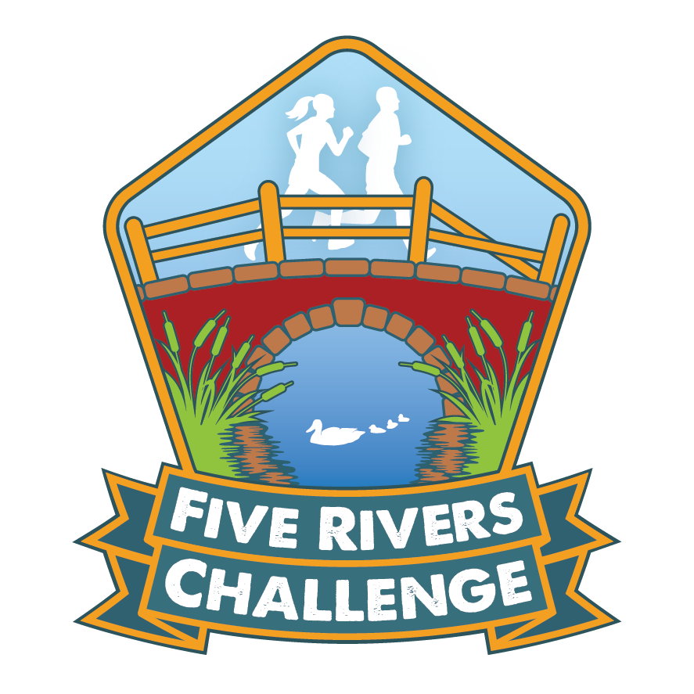
Emergency Contact Numbers for Race Directors
Colin Grace: 07769 880809
Mark Blanchard: 07864 572088
Race HQ: Allenburys Sports & Social Club, Harris Lane, Ware, Herts SG12 0DJ

